DATA EXPLORATION AND VISUALIZATION

EXPERIMENT 1 – BASIC VISUALIZATION IN VARIOUS TOOLS

1)PYTHON

LINE PLOT:

import matplotlib.pyplot as plt

X=[1,2,3,4,5]

Y=[10,20,30,40,50]

plt.plot(X,Y)

plt.show()

OUTPUT:

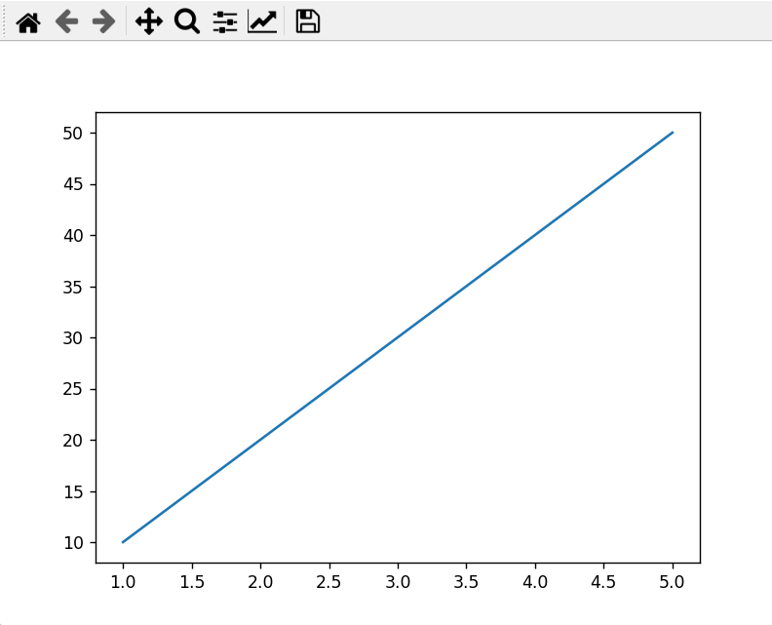

BAR PLOT:

import matplotlib.pyplot as plt

fruits=["Apple","Banana","Cherry","Watermelon","Mango"]

sales=[400,350,300,450,500]

plt.bar(fruits,sales)

plt.title("fruit sales")

plt.xlabel("fruits")

plt.ylabel("sales")

plt.show()

OUTPUT:

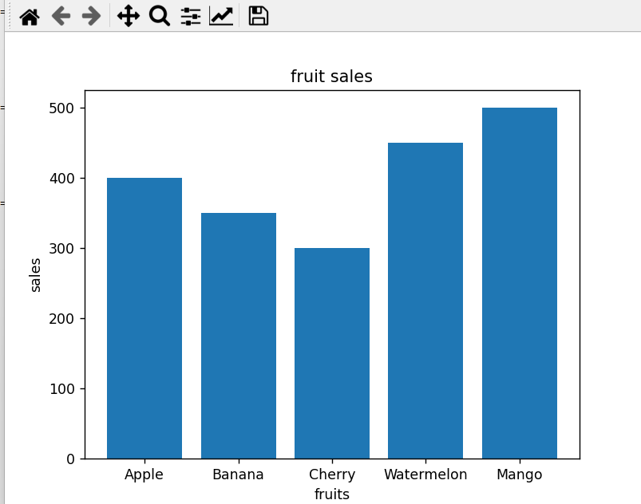

2)R STUDIO:

x <- c(1,2,3,4)

y <- c(10,20,25,30)

plot(x,y,type="o",col="blue",main='Simple Line plot',xlab="X- axis",ylab="Y-axis")

OUTPUT:

